**Exploring Consumer Electronics Shopping Behaviour: Showrooming vs. Webrooming Trends**

**Team members**

Shubham Gupta DM243080

Tavishi Mehta DM241086

Lekha Sharma DM241043

Mentored by: Anbumathi. R - Anbumathi.r@greatlakes.edu.in

2024

**Contents**

**Abstract** 3

**Introduction** 3

**Synopsis** 4

**Executive Summary** 5

**Literature Review** 6

**Proposed Methodology** 11

**Reliability Analysis** 13

**Results** 14

Table 1: Classification of Demographics Data 15

Table 2: Variation Inflation Factor (VIF) values and Fornell Larcker Criterion 17

Table 3: Fornell Larcker Criterion 18

Table 4: Convergent Validity Measures 19

Table 5: Factor Loading 20

Table 6: Structural Model Final Results 21

**Discussion and Results** 22

**Conclusion** 24

**References** 25

**Appendix** 27

# 

# **Abstract**

In the dynamic landscape of consumer electronics purchasing, a new shopping paradigm has emerged: the interplay of showrooming and webrooming behaviours. Showrooming entails physical product inspection before online purchase, while webrooming involves online research culminating in in-store transactions. This empirical research delves into the motivations behind these behaviours, focusing on critical factors like price comparison, in-store experience, trust, convenience, and demographic influences.

Employing a robust mixed-methods approach, the study utilizes surveys, statistical analyses, in-depth interviews, and sentiment analysis to provide a comprehensive understanding of showrooming and webrooming within the electronics industry.

The anticipated outcomes are multifaceted. The research will provide actionable recommendations for retailers to refine their strategies, enhance customer experiences, and adapt to evolving consumer preferences. Additionally, the findings will underscore the importance of cultural nuances in shaping these behaviours, while suggesting avenues for future exploration into other variables influencing consumer shopping behaviours in the digital age.

# **Introduction**

The dynamic landscape of consumer electronics purchasing is undergoing a fascinating transformation. This research delves into the intriguing dichotomy of showrooming and webrooming behaviours, aiming to illuminate the motivations behind these contrasting yet prevalent practices.

Our interest in this topic stems from the burgeoning presence of both showrooming and webrooming within the electronics industry. Consumers are increasingly leveraging both online and offline channels throughout their purchase journey. In this sector, where detailed product specifications and intricate comparisons are crucial, the interplay between physical inspection and web-based research thrives. This convergence of online and offline influences compels a deeper exploration into the factors that drive consumers to adopt showrooming or webrooming behaviours.

This study aspires to achieve two key outcomes. Firstly, we aim to establish a comprehensive understanding of the prevalence and driving forces behind showrooming and webrooming within the electronics domain. By examining factors such as price comparison, in-store experience, trust, product research, convenience, instant gratification, security, and demographic influences, we can gain valuable insights into the decision-making calculus of consumers. Secondly, we seek to translate these insights into actionable recommendations for electronics retailers. By equipping them with a deeper understanding of these consumer behaviours, retailers can refine their strategies and enhance customer experiences, ultimately navigating the evolving retail landscape more effectively.

This research will contribute meaningfully to the ongoing dialogue on consumer behaviour within the electronics industry. The findings hold significant value for both academic audiences and industry stakeholders. For academics, the study offers a rich tapestry of data that can illuminate the complexities of consumer decision-making in the digital age. Industry stakeholders, on the other hand, can leverage the findings to develop strategic insights that can inform future practices and empower informed decision-making. By bridging the gap between academic inquiry and practical application, this research has the potential to shape the future of customer experiences within the electronics retail sector.

**Topic:** Exploring Consumer Electronics Shopping Behaviour: Showrooming vs. Webrooming Trends

# **Synopsis**

This empirical study will investigate the dichotomy of consumer behaviour in the electronics industry, focusing on showrooming, where consumers inspect products in-store but buy online, and webrooming, where online research precedes in-store purchases. We would examine factors such as price comparison, in-store experience, trust, product research, convenience, instant gratification, security, demographic influences etc to gain insights into the motivations behind these behaviours. The electronics industry serves as an ideal backdrop for this research because consumers in the electronics sector often use both online and offline channels to gather information and make purchases.

To achieve a holistic understanding, this empirical study will employ a robust mixed-methods approach. Quantitatively, a substantial survey will be conducted among a diverse cross-section of consumers in the electronics market. Survey questions will delve into the various shopping behaviours. Statistical analyses will be employed to reveal correlations and significance using hypothesis testing for regression analysis and ANOVA. Qualitatively, in-depth interviews and focused group discussions will be conducted with selected participants to glean profound insights into their motivations and decision-making processes. Qualitative data will be methodically analysed to unearth meaningful patterns and themes using sentiment analysis.

The anticipated outcomes of this study encompass a comprehensive understanding of the prevalence and the motivating factors behind showrooming and webrooming behaviours within the electronics industry. Additionally, the research endeavours to offer practical recommendations for retailers in the electronics sector to refine their strategies and enhance customer experiences, thereby adeptly accommodating the nuances of these increasingly prominent shopping behaviours. This research ultimately aims to empower stakeholders to navigate the dynamic landscape of consumer electronics purchasing decisions more effectively.

# **Executive Summary**

In the dynamic realm of consumer behaviour within the electronics industry, this empirical study explores the intricate dynamics of showrooming and webrooming. Webrooming, a practice where consumers conduct online research before making offline purchases, takes centre stage in the study. Focused on the consumer electronics sector, where the fusion of online and offline channels is ubiquitous, the research delves into key variables—price comparison, in-store experience, trust, product research, convenience, instant gratification, security, and demographic influences—to unveil the motivations driving these distinct behaviours.

The practice of webrooming is driven by multiple factors, signalling shifts in consumer shopping behaviour in the digital era. Consumers engage in webrooming to gather information, including reading reviews, comparing features, and seeking recommendations before committing to a purchase. Price comparison emerges as a significant factor, with individuals strategically assessing online and offline prices to secure the best deals. Webrooming also serves as a means of product discovery, enabling consumers to identify new items.

Furthermore, webrooming plays a crucial role in consumer education, aiding individuals in preparing for in-store experiences by familiarizing themselves with products online. The study seeks to investigate whether dissatisfaction with showrooming steers consumers towards a preference for webrooming. Addressing this question, we operationalize the Expectation Disconfirmation Theory, focusing on how satisfaction or dissatisfaction is shaped by the alignment of a product or service's actual performance with initial expectations. Satisfaction is posited to hinge on whether the performance meets, exceeds, or falls short of expectations, and this model will be rigorously tested using structural equation modelling.

The sampling strategy employs purposive sampling, concentrating on Generation Z respondents due to the observed prevalence of webrooming behaviour within this demographic. This approach aims to provide valuable insights into the evolving trends shaping the future of consumer electronics purchasing decisions.

The study endeavours to offer a comprehensive understanding of showrooming and webrooming prevalence, unravelling the underlying motivations. Utilizing a blend of statistical and qualitative analyses, the research seeks to uncover meaningful patterns and themes. Ultimately, the goal is to empower retailers in the electronics sector with practical recommendations, enriching strategies and customer experiences to adeptly navigate the nuanced landscape of these prominent shopping behaviours. This report contributes to the ongoing discourse on consumer behaviour, offering insights that are not only academically enriching but also strategically valuable for industry stakeholders.

# **Literature Review**

|  |  |  |  |  |  |  |
| --- | --- | --- | --- | --- | --- | --- |
| **S.No** | **Author & year** | **Study type** | **Sample** | **Country & Sector** | **Theme of the article** | **Scope for Further Study/Limitations** |
| 1 | Reid et.al. 2016 | Cross-Sectional | 109 | UK, Apparels | The study explores how consumers' product selection criteria relate to 'show-rooming' and 'web-rooming' in clothing purchases. Price doesn't impact 'show-rooming' significantly, but there's a weak positive correlation, suggesting some engage for financial gain. 'Garment fit' and 'quality' don't affect 'web-rooming,' with a weak negative correlation as their importance decreases. However, visual appearance significantly influences 'web-rooming.' Retailers need to improve the consumer's evaluative process, noting the unique characteristics of clothing purchases. | Future research should consider expanding sample size and demographic diversity to improve external validity. Utilizing qualitative methods like interviews or focus groups could offer deeper insights into consumer motivations. Comparative studies across different consumer goods sectors could unveil sector-specific factors affecting 'show-rooming' and 'web-rooming.' Additionally, investigating variables like brand loyalty or social influence could enhance understanding of consumer channel behavior. |
|  |
|  |
|  |
|  |
|  |
|  |
|  |
| 2 | Sit et. al. 2018 | Qualitative investigation via a consumer-experience lens | 11 self-proclaimed showroomers | Not mentioned, Electronics | The study's results present an alternative perspective on showrooming, revealing that it can be understood as a positive consumer behaviour when viewed through the lens of consumer experience. It identifies four decision activity stages that showroomers go through—problem recognition and information search, evaluation, purchase, and post-purchase. The research also highlights the emotions showroomers experience during these stages, offering practical implications for retailers to better serve showroomers and potentially transform this behaviour into a positive experience for both customers and businesses. | One notable limitation is the relatively small and homogenous sample of participants, which may restrict the broader applicability of the findings. The study's focus on the during-shopping process and limited exploration of the post-purchase stage leaves room for further investigation. Additionally, the research primarily considers the perspective of consumers, overlooking the experiences and insights of other relevant stakeholders. |  |
| 3 | Aw 2019 | Cross-Sectional | 300 | Malaysia, E-Commerce | The study aims to understand the impact of factors such as why people shop, what they think they'll gain from online shopping, and what it cost them influence their intention to webroom. We found out that customers who are motivated by efficiency shopping, bargain hunting and variety seeking are more likely to engage in webrooming. The study also found that avail of sales people, immediate possession, low purchase effort is likely to engage in webrooming. On the other hand, long delivery time, expected price loss are less likely to engage in webrooming. | The research was limited to university students, affecting the generalizability of its findings. Additionally, it solely focused on apparel products, overlooking other potential categories. Further exploration into various shopping motivations like gift shopping, sensory stimulation, and socialization could enrich future studies. Moreover, investigating the role of psychographic variables in webrooming could offer valuable insights into consumer behavior. |  |
|  |
|  |
| 4 | Flavian et.al. 2021 | Cross-Sectional | 204 | Spain, Electronics and Fashion | The study aims at examining the impact of m-WOM on consumer behaviour, here it focuses on two products being electronics and fashion. An online webrooming experience was prepared where everyone was assigned one of the two product categories and he needs to answer series of question about the in-store use of smartphone in their purchasing behaviour and preferences for categories. The participants indicated the degree of familiarity and the knowledge of product category, ranked across 6 bands according to their preference. The study considers trust and expertise as mediating effects and consumer demographics, online shopping experience as control variable | The study conducted online experiments instead of offline store experiments. However, the limited sample size hinders the generalization of results. Furthermore, without manipulation checks on social relationships, conclusions about the effects of friends or anonymous customers remain uncertain. Additionally, the research focused solely on electronics and fashion accessories, limiting the generalizability of the assessment. |  |
| 5 | Azogue 2021 | Cross-Sectional | 659 | Spain, None | The article delves into consumer intention for mobile-assisted showrooming, analysing factors like technology acceptance, value consciousness, and purchase involvement. Hedonic motivation and social influence are key drivers, while value consciousness and purchase involvement strongly impact showrooming intention. Interestingly, high mobile dependency weakens the link between value consciousness and showrooming, indicating that smartphone habits may drive online purchases instead of seeking post-store deals. | Examining a broader range of product categories and considering the intentionality of the behaviour could provide deeper insights. Additionally, exploring the impact of variables like age, gender, and experience on mobile showrooming behaviour would be valuable. Further investigation into the unexpected moderating effect of mobile dependency on the relationship between value consciousness and showrooming intention is warranted to better comprehend this relationship and its implications. |  |
|  |
| 6 | Shankar et.al. 2021 | Cross-Sectional | 428 | India, E-Commerce | The study investigated how online engagement affects webrooming intention, considering perceived value and risk. Results from a bilingual survey showed that online engagement boosts perceived value, promoting webrooming. However, online risk perception dampens this relationship. Marketers should focus on enhancing perceived value and reducing online risk to encourage webrooming behavior, benefiting multi-channel retailers. | To enhance the generalizability of results, employing a longitudinal survey would be preferable. Additionally, incorporating various moderating variables such as demographic profile, product type, and consumer innovativeness could offer deeper insights. Multi-group analysis could be conducted to compare results across different segments. Moreover, as the study solely focused on the Indian consumer, its findings may be limited in their applicability to other contexts. |  |
|  |
| 7 | Fernández et.al. 2022 | Cross sectional | 847 | Spain, Apparel | The analysis of webrooming and showrooming behaviours in omni-shoppers. The article explores the drivers and factors related to these behaviours, including the individual's willingness to adopt ICT and the way shoppers search for, select, and evaluate information. The study aims to contribute to the emerging literature on consumer behaviour in the fashion sector by testing a model that explains the intentions of individuals to adopt webrooming and showrooming. | The article suggests delving into various omni-channel practices and drivers like hedonic or utilitarian perceptions of products to understand consumer behavior in retail. Future research could explore diverse retail sectors for a comprehensive view. However, the study's cross-sectional design limits insights, focusing mainly on behavioural intentions rather than actual behavior. Further investigation is proposed to explore additional omni-channel drivers. |  |
|  |
| 8 | Khoshtaria et.al. 2022 | Quantitative Study | 424 | Georgia, Retail | The study examines showrooming and webrooming, where customers research products online before buying either online or in-store. It explores how purchasing patterns like basket size, frequency, and value relate to this behavior. Findings show a negative link between basket size/frequency and showrooming/webrooming, rejecting a strong positive correlation with monetary value and online research. | Consumers expand their preferences by incorporating new options, allowing retailers to access a wider audience. Both online-only and brick-and-mortar stores face the risk of losing customers without diverse distribution channels. Embracing a multi-channel approach helps retailers adapt to changing consumer trends and stay ahead in the competitive landscape. |  |
|  |
| 9 | Holkkola et.al. 2022 | Cross sectional | 1028 | Finland, None | The study is to examine the associations between socio-demographic factors and showrooming behaviour on mobile devices. The study aims to identify which consumer groups based on age, gender, and income level are more likely to engage in showrooming and to what extent these variables explain showrooming behaviour. The study also focuses on different forms of showrooming, such as searching for information and better prices for products. | Future research should replicate the study across diverse cultural contexts to validate socio-demographic factors influencing showrooming behavior. It should also include online channels to better understand showrooming prevalence. Qualitative methods can delve into motivations, including gender effects and attitudes toward online consumer behavior. |  |
|  | Olearova et.al. 2022 | Cross-Sectional | 208 | Slovakia, Clothes and Footwear | The study compares webrooming and showrooming perceptions in clothing and footwear, focusing on perceived risk, enjoyment, and shopping channel attitude. Descriptive statistics reveal higher median perceived usefulness for webrooming. It also delves into entrepreneurship and sustainability in the fashion industry. | The study's methods didn't accurately capture consumer behavior when switching between online and offline mediums. Limited observations hindered result generalization. |  |
| 10 |  |
| 11 | Zaharaet.al. 2022 | Mixed both Qualitative and Quantitative | 601 | Indonesia, Fashion Products | The study aims to identify the factors that drive webrooming behaviour among millennials. They used combination of qualitative and quantitative surveys with structural equation model. They identified several factors which drive Gen Y Consumers like convenience, social influence, price comparison and product assortment. They provide a framework for retailer to implement for making omnichannel shopping successful. | The study's reliance on a systematic literature review may overlook important factors influencing webrooming behavior. A larger sample size of Gen Y would have improved result generalization. Future research could investigate factors like technological advancements and economic conditions. Additionally, exploring demographics within Gen Y, including age, gender, income, and education level, could provide deeper insights. |  |
| 12 | Olearova et.al. 2022 | Cross sectional | 486 | Slovakia, Fashion | The theme of the article is to explore the shopping motives that lead consumers to prefer individual shopping channels, specifically webrooming and showrooming. The research aims to understand the three-dimensional structure of smart shopping perception and how it influences consumer behaviour in choosing between online and offline channels. The article discusses the modification of scenarios and data collection process, as well as the need for further research to examine channel switching and broaden the understanding of shopping motives. | The research recommends exploring different product categories beyond fashion, and investigating channel switching among individuals experienced with multiple stores. Expanding the smart shopping structure to include additional motives could provide deeper insights. However, limitations include using cross-sectional data influenced by the pandemic and a predominantly female sample, potentially overlooking male preferences. |  |
| 13 | Chimborazo-Azogue et.al. 2022 | Cross-Sectional | 659 | Spain, M-Wom | The study explores the impact of mobile dependency and uncertainty reduction strategies on showrooming behaviour and user generated content creation. They used partial least square structural equation modelling to test and evaluating the model. Results show that mobile dependency and uncertainty reduction strategy have significant impact on showrooming behaviour and user generated content creation. | The study examined showrooming behavior in individuals with past engagement, emphasizing the influence of prior behavior. However, testing only two product categories restricts generalization; future research should validate across a broader range. Additionally, the study overlooks experience's role and cultural differences, highlighting areas for further investigation. |  |
| 14 | Goraya et.al. 2022 | Cross-sectional | 353 | China, electronics (as search products) and clothing (as experience products) | The study discovered that channel integration has a positive influence on consumers' intentions to patronize both online and offline stores, emphasizing the importance of offering integrated shopping experiences. Three key mediating factors - empowerment, assortment, and benefits - were identified, underlining their roles in shaping consumer patronage intentions. Moreover, the study introduced showrooming and webrooming as moderating factors, showing how they impact the relationship between channel integration and online/offline store patronage intentions based on the product type. This research provides valuable insights for retailers and researchers, helping them navigate the complexities of integrated channel shopping. | The study primarily focused on online and offline integrated channels, leaving out other potential integrated channels like mobile devices and brand advertisements. It didn't account for various moderating and intervening factors such as gender, store environments, or consumer personality traits, which could impact patronage intentions. It's important to note that the study assessed consumer patronage intentions, not actual behaviours, and its findings might not fully represent real-world consumer actions. Additionally, the study was conducted with Chinese consumers, and different geographical regions may have varying perceptions and behaviours regarding integrated channels, making generalization challenging. |  |
|  |
| 15 | Halibas et.al. 2023 | Qualitative study- bibliometric analysis of 500 papers from Scopus database | NA | Vietnam, none | The article's primary focus is on the research and channel shopping behaviour (RCSB) domain, to reveal its knowledge structure and evolution. The study shows a steady growth in research interest within the domain, with key authors and themes identified. It presents a framework of five distinct clusters of studies in the RCSB field, along with evolving themes, particularly the emergence of customer experience, channel choice, multichannel, and the impact of the Covid-19 pandemic. This research provides a valuable resource for future scholars and researchers exploring shopping behaviours in the retail and channel context. | Future research in the realm of retail and channel shopping behaviours can investigate the impact of cutting-edge digital services, such as augmented reality and proximity marketing, on the shopping experiences of omnichannel consumers. Understanding the decision-making processes behind channel choices in e-commerce, mobile commerce, and social commerce can help businesses tailor effective marketing strategies. Moreover, studies can delve into the factors influencing channel selection, such as pricing strategies and environmental concerns. To address disruptions, businesses should be equipped with flexible omnichannel strategies and advanced logistics. |  |
| 16 | Wu 2023 | Experiment | 354 | Malaysia, None | The article is the phenomenon of webrooming, which refers to the behaviour of consumers researching products online and then making their purchase in physical stores. The article explores the factors that influence consumers' perception of webrooming as a smart shopping method, such as anticipated regret and after-sales service convenience. It also discusses the implications for retailers, including the need to leverage webrooming to drive store traffic and the importance of addressing consumers' diverse decision-making contingencies. | The study's limitation to Chinese respondents restricts generalizability to other cultures. Future research should include participants from diverse cultural backgrounds to enhance applicability. The structural model analysis revealed no multicollinearity concerns, with VIF values below the threshold of 3.3. However, further exploration in different contexts or with different variables is warranted. Additionally, while 5 out of 8 mediation paths were significant, future studies could investigate the remaining paths for a more comprehensive understanding of variable relationships. |  |
| 17 | Frasquet et.al 2023 | Experiment | 466 | Spain, Appliances and clothing and footwear | The article explores the factors that influence showrooming behaviour, such as online price advantage, salesperson quality, and retailer loyalty. It also discusses the role of smartphones and the importance of providing a good shopping experience to counteract showrooming. The article suggests that retailers should focus on improving service quality and implementing strategies to enhance customer loyalty. | Future research should analyze contextual factors influencing showrooming behavior and encompass diverse behavioral responses. It should measure both competitive and loyal showrooming intentions while exploring other shopper behaviors. Additionally, further exploration should consider additional retailer-related and situational factors. |  |
| 18 | Schiessl et.al. 2023 | Cross-Sectional | 626 | Brazil, Ecommerce | The study explores the impact of poor online experience on consumer intention to do webrooming. We fended out that poor online experience can lead to frustration and decreases the consumer intention to purchase online from the same store. The trigger of poor experience did not significantly impact the intensity of experience. They used LWIC software to analyse the text explaining poor experience and found that emotions like anxiety, anger and sadness impact the repurchase intention. | Research could explore if achieving consumer goals during the purchase process reduces the intention to webroom. Utilizing advanced data analysis methods like big data or neural networks could enhance data analysis. Companies could measure customer frustration using heart rate or facial expression. However, online experiments may not fully capture real-world complexities. |  |
|  |
|  |
|  |
|  |
|  |
|  |
|  |
|  |
|  |
| 19 | Shankar and Jain 2023 | Cross-Sectional | 374 | India, Fashion Products | The study explores why luxury consumers engage in webrooming and what factor influences it. They found that social norms, gender, and age all have impact on luxury consumers webrooming behaviour. Young consumer who generally are more accustomed with technology are more likely to engage in webrooming. The study recommends retailer to make offline information search convenient for consumer. The study even contributes to luxury marketing and retailing literature by examining luxury consumers webrooming intention. | The study focused solely on luxury consumers, limiting the generalizability of findings. Future research could employ the theory of planned behavior to delve deeper into luxury consumers' webrooming intentions. Additionally, conducting multi-group analysis based on income, education, and qualifications could provide a more nuanced understanding of the phenomenon. |  |

# **Proposed Methodology**

Based on the above review of literature a conceptual model will be developed based on the identified independent variables and dependent variable. Further after receiving responses, the model will be tested adapting Structural Equation Modelling (SEM) technique using Smart PLSv4.0 software.

The proposed sampling technique is purposive sampling and the respondents will be Gen Z respondents as the webrooming behaviour is mostly prevalent among the Generation Z.

**Product Conceptual Model:**

Disconfirmation Showrooming

Dissatisfaction Showrooming

Intention to Webrooming

Expectation Webrooming

Figure 1 Product Conceptual Model on Webrooming

Customers' expectations can significantly influence their shopping behavior, particularly when it comes to the interplay between physical stores (showrooming) and online platforms (webrooming). This model highlights how disconfirmation of expectations, positive towards webrooming or negative towards showrooming, can lead to dissatisfaction and ultimately a higher intention to webroom.

Let's consider the scenario of a negative showrooming experience. Customers typically anticipate a positive in-store experience with helpful staff, a wide range of products to explore, and a smooth checkout process. However, when reality falls short, with unhelpful staff, limited product availability, or long lines, it leads to disconfirmation and dissatisfaction with showrooming. This negative experience can then nudge them towards considering webrooming for future purchases in hopes of a more satisfying experience.

On the other hand, even positive expectations towards webrooming can lead to the same outcome. Customers might anticipate a user-friendly online experience with easy navigation, clear product descriptions, secure payment options, and fast delivery. But if the reality involves a complex website, unclear descriptions, checkout difficulties, or slow delivery times, it can result in dissatisfaction with webrooming. Interestingly, this negative experience can also make them less likely to consider webrooming again, pushing them back towards showrooms in the future.

In essence, this model suggests that regardless of the initial channel (physical store or online), failing to meet expectations fosters dissatisfaction and ultimately steers customers towards webrooming, where they hope for a more fulfilling shopping experience. By understanding these dynamics, retailers can strive to improve customer experience in both their physical stores and online platforms, minimizing disconfirmation and fostering long-term customer satisfaction..

# **Reliability Analysis**

|  |  |
| --- | --- |
| Dependent Variable | Cronbach's alpha |
|  |  |
| Webrooming Intention | 0.859 |

|  |  |
| --- | --- |
| Independent Variables | Cronbach's alpha |
|  |  |
| Convenience | 0.821 |
| Disconfirmation Showrooming | 0.818 |
| Expectation Webrooming | 0.851 |
| Financial Risk | 0.743 |
| Immediate Possession | 0.824 |
| Product Risk | 0.853 |
| Sales Staff Assistance | 0.826 |
| Socialisation | 0.811 |
| Touch and Feel Experiance | 0.717 |

* All reported Cronbach's alpha values exceed 0.7, indicating good to excellent internal consistency for the respective variables.
* Specific values range from 0.717 (acceptable) for "Touch and Feel Experience" to 0.859 (excellent) for "Webrooming Intention."

The reported Cronbach's alpha values suggest good to excellent internal consistency for most variables, supporting the reliability of the measures used in the research. However, further examination of the "Touch and Feel Experience" variable is recommended. Overall, the analysis strengthens the credibility of the findings and their implications

# **Results**

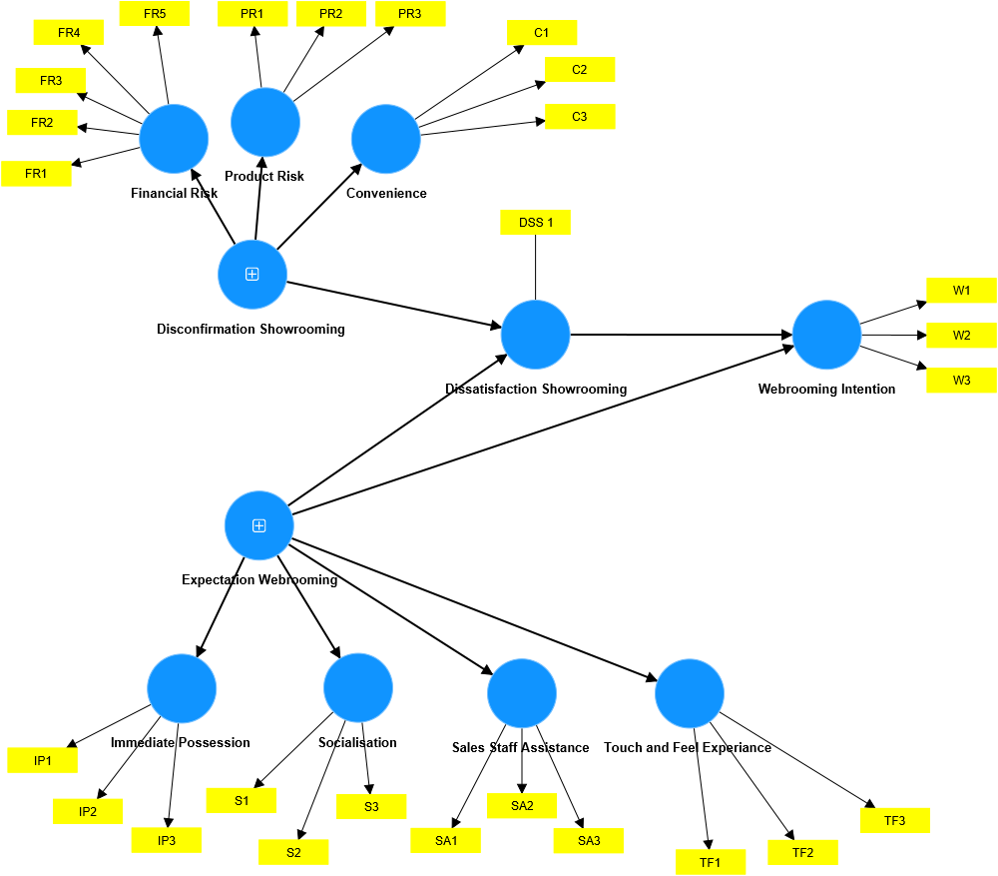

Figure 2 The Model Shows the Relationship between Dependent and Independent variable

## Table 1: Classification of Demographics Data

|  |  |  |
| --- | --- | --- |
| **Total Responses** | | 167 |
|  |  |  |
| **Gender** | Male | 102 |
|  | Female | 65 |
|  |  |  |
| **Age Range** | Below 18 | 9 |
|  | 18-22 | 61 |
|  | 23-27 | 89 |
|  | 28-32 | 2 |
|  | 32-36 | 2 |
|  | Above 36 | 4 |
|  |  |  |
| **How often do you purchase electronic gadgets (e.g. Mobiles, Laptop, Smart Watch, Speaker, iPad etc.)  online?** | Never | 6 |
| Occasionally | 68 |
| Sometimes | 55 |
| Often | 26 |
|  | Always | 12 |
|  |  |  |
| **Recency of Purchase** | Last Week | 9 |
|  | Last Month | 25 |
|  | Last 3 Months | 40 |
|  | Last 6 Months | 36 |
|  | Last Year | 25 |
|  | More than 1 Year | 32 |
|  |  |  |
| **Preferred online site for Electronics** | Amazon | 103 |
|  | Flipkart | 33 |
|  | Croma | 17 |
|  | Vijay Sales | 9 |
|  | Brand Specific Website | 5 |

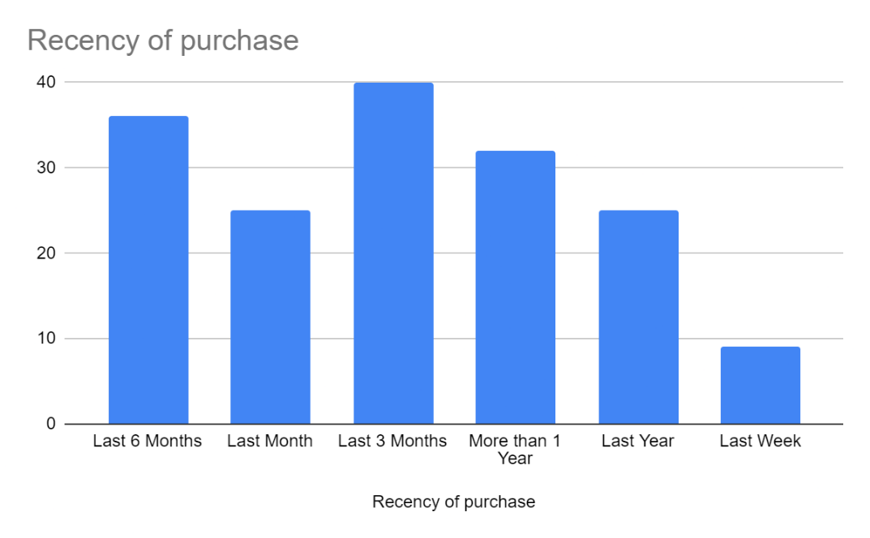 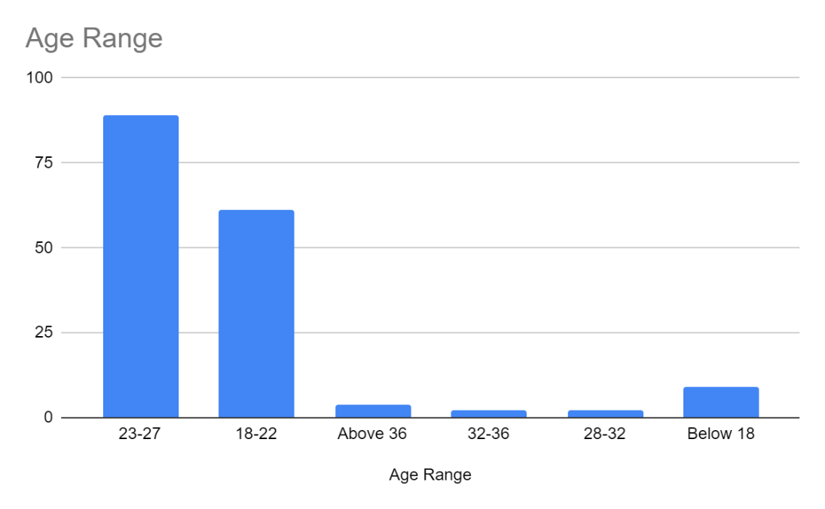 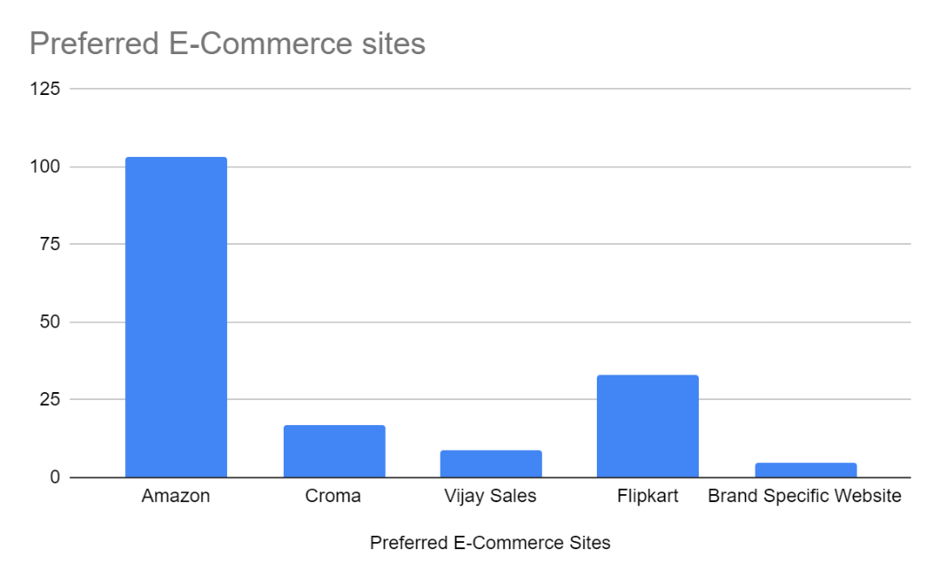 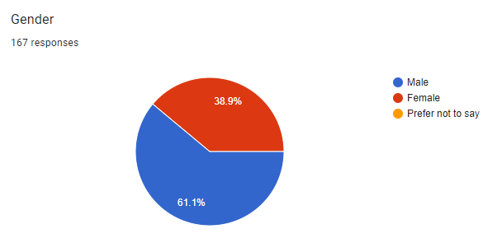

## Table 2: Variation Inflation Factor (VIF) values and Fornell Larcker Criterion

**Insights**

* All of the VIF values in your table are less than 3, ranging from 1.000 (DSS) to 2.937 (SA1).
* This suggests that multicollinearity is not a major concern in our analysis. We can be confident that the variance of your estimated regression coefficients is not being inflated significantly due to collinearity among the independent variables.

|  |  |  |  |
| --- | --- | --- | --- |
| Variables | VIF | Variables | VIF |
| C1 | 2.136 | PR2 | 2.342 |
| C1 | 2.39 | PR2 | 2.16 |
| C2 | 1.821 | PR3 | 2.132 |
| C2 | 1.969 | PR3 | 2.246 |
| C3 | 1.851 | S1 | 1.736 |
| C3 | 1.731 | S1 | 2.075 |
| DSS 1 | 1 | S2 | 2.015 |
| FR1 | 1.518 | S2 | 1.697 |
| FR1 | 1.71 | S3 | 2.404 |
| FR2 | 1.527 | S3 | 2.108 |
| FR2 | 1.346 | SA1 | 2.108 |
| FR3 | 1.304 | SA1 | 2.937 |
| FR3 | 1.193 | SA2 | 2.543 |
| FR4 | 1.809 | SA2 | 2.394 |
| FR4 | 1.674 | SA3 | 2.009 |
| FR5 | 1.603 | SA3 | 1.612 |
| FR5 | 1.724 | TF1 | 2.134 |
| IP1 | 1.862 | TF1 | 1.855 |
| IP1 | 1.741 | TF2 | 1.175 |
| IP2 | 2.237 | TF2 | 1.442 |
| IP2 | 2.034 | TF3 | 2.123 |
| IP3 | 1.95 | TF3 | 1.899 |
| IP3 | 1.88 | W1 | 2.376 |
| PR1 | 2.019 | W2 | 2.514 |
| PR1 | 2.158 | W3 | 1.887 |

## 

## Table 3: Fornell Larcker Criterion

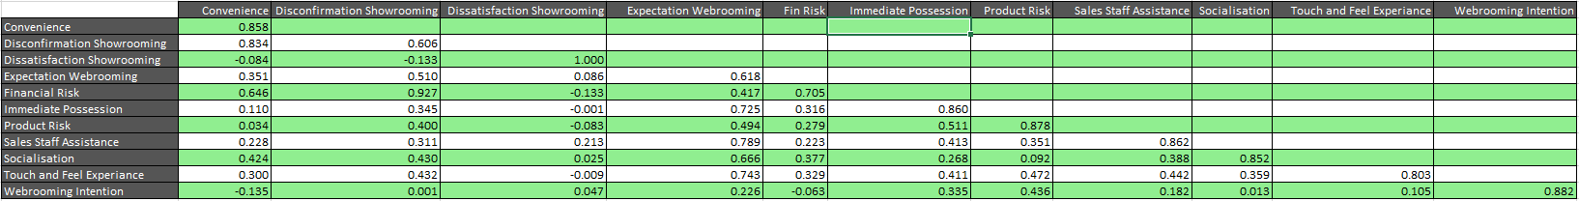

The Fornell-Larcker criterion is a measure of discriminant validity used in structural equation modelling (SEM) to assess whether a construct is distinct from other constructs in the model. It is based on the idea that the average variance extracted (AVE) of a construct should be greater than the squared correlations between that construct and any other construct in the model.

The table shows the Fornell-Larcker criteria for several constructs. The AVE values are shown on the diagonal of the table, and the squared correlations are shown below the diagonal.

Here are some of the key observations from the table:

* All of the AVE values are greater than 0.5, which is generally considered to be a good indication of discriminant validity.
* Most of the squared correlations are below the corresponding AVE values, which also supports discriminant validity.

## Table 4: Convergent Validity Measures

|  |  |  |  |  |
| --- | --- | --- | --- | --- |
|  | Composite reliability | Composite reliability | Average variance extracted | Cronbach's alpha |
| Convenience | 0.824 | 0.894 | 0.737 | 0.821 |
| Disconfirmation Showrooming | 0.845 | 0.856 | 0.367 | 0.818 |
| Expectation Webrooming | 0.856 | 0.880 | 0.382 | 0.851 |
| Financial Risk | 0.752 | 0.830 | 0.496 | 0.743 |
| Immediate Possession | 0.826 | 0.895 | 0.740 | 0.824 |
| Product Risk | 0.881 | 0.909 | 0.770 | 0.853 |
| Sales Staff Assistance | 0.827 | 0.897 | 0.743 | 0.826 |
| Socialisation | 0.812 | 0.888 | 0.726 | 0.811 |
| Touch and Feel Experience | 0.745 | 0.843 | 0.645 | 0.717 |
| Webrooming Intention | 0.912 | 0.913 | 0.778 | 0.859 |

The table shows that for most constructs, the composite reliability, CRVE, and Cronbach's Alpha are all above 0.8, which indicates good reliability. The AVE is above 0.5 for most constructs, indicating good convergent validity. Convergent validity means that the measures are related to the construct they are supposed to measure.

Here are some specific findings in the table, though it is important to note that without knowing more about the study, it is difficult to draw strong conclusions:

* Customers seem relatively satisfied with the helpfulness of the sales staff (Convenience) and the touch-and-feel experience (Touch and Feel Experience).
* There seems to be lower satisfaction with financial risk (e.g., concerns about returns or warranty policies) and showrooming disconfirmation (dissatisfaction with the in-store experience relative to expectations).

## Table 5: Factor Loading

|  |  |  |  |
| --- | --- | --- | --- |
| **Factors** | **Factor loadings** | **Factors** | **Factor loadings** |
| C1 <- Convenience | 0.891 | PR2 <- Product Risk | 0.874 |
| C1 <- Disconfirmation Showrooming | 0.752 | PR2 <- Disconfirmation Showrooming | 0.326 |
| C2 <- Convenience | 0.85 | PR3 <- Disconfirmation Showrooming | 0.29 |
| C2 <- Disconfirmation Showrooming | 0.713 | PR3 <- Product Risk | 0.859 |
| C3 <- Disconfirmation Showrooming | 0.681 | S1 <- Socialisation | 0.845 |
| C3 <- Convenience | 0.833 | S1 <- Expectation Webrooming | 0.59 |
| DSS <- Dissatisfaction Showrooming | 1 | S2 <- Socialisation | 0.836 |
| FR1 <- Disconfirmation Showrooming | 0.687 | S2 <- Expectation Webrooming | 0.576 |
| FR1 <- Financial Risk | 0.736 | S3 <- Socialisation | 0.876 |
| FR2 <- Financial Risk | 0.654 | S3 <- Expectation Webrooming | 0.531 |
| FR2 <- Disconfirmation Showrooming | 0.607 | SA1 <- Sales Staff Assistance | 0.872 |
| FR3 <- Disconfirmation Showrooming | 0.553 | SA1 <- Expectation Webrooming | 0.707 |
| FR3 <- Financial Risk | 0.588 | SA2 <- Expectation Webrooming | 0.658 |
| FR4 <- Disconfirmation Showrooming | 0.708 | SA2 <- Sales Staff Assistance | 0.893 |
| FR4 <- Financial Risk | 0.764 | SA3 <- Expectation Webrooming | 0.673 |
| FR5 <- Disconfirmation Showrooming | 0.697 | SA3 <- Sales Staff Assistance | 0.82 |
| FR5 <- Financial Risk | 0.764 | TF1 <- Touch and Feel Experiance | 0.863 |
| IP1 <- Immediate Possession | 0.843 | TF1 <- Expectation Webrooming | 0.643 |
| IP1 <- Expectation Webrooming | 0.614 | TF2 <- Expectation Webrooming | 0.49 |
| IP2 <- Expectation Webrooming | 0.65 | TF2 <- Touch and Feel Experiance | 0.655 |
| IP2 <- Immediate Possession | 0.882 | TF3 <- Expectation Webrooming | 0.644 |
| IP3 <- Immediate Possession | 0.856 | TF3 <- Touch and Feel Experiance | 0.873 |
| IP3 <- Expectation Webrooming | 0.608 | W1 <- Webrooming Intention | 0.919 |
| PR1 <- Product Risk | 0.899 | W2 <- Webrooming Intention | 0.883 |
| PR1 <- Disconfirmation Showrooming | 0.415 | W3 <- Webrooming Intention | 0.842 |

## Table 6: Structural Model Final Results

|  |  |  |  |  |  |
| --- | --- | --- | --- | --- | --- |
|  | Sample mean (M) | Std deviation (STDEV) | T statistics | P values |  |
| Disconfirmation Showrooming -> Convenience | 0.839 | 0.039 | 21.281 | 0.000 | Significant |
| Disconfirmation Showrooming -> Dissatisfaction Showrooming | 0.105 | 0.088 | 1.207 | 0.227 | Not Significant |
| Disconfirmation Showrooming -> Financial Risk | 0.925 | 0.018 | 50.449 | 0.000 | Significant |
| Disconfirmation Showrooming -> Product Risk | 0.387 | 0.120 | 3.271 | 0.001 | Significant |
| Dissatisfaction Showrooming -> Webrooming Intention | 0.022 | 0.080 | 0.356 | 0.722 | Not Significant |
| Expectation Webrooming -> Dissatisfaction Showrooming | 0.010 | 0.088 | 0.068 | 0.946 | Not Significant |
| Expectation Webrooming -> Immediate Possession | 0.728 | 0.049 | 14.688 | 0.000 | Significant |
| Expectation Webrooming -> Sales Staff Assistance | 0.788 | 0.043 | 18.252 | 0.000 | Significant |
| Expectation Webrooming -> Socialisation | 0.665 | 0.067 | 9.920 | 0.000 | Significant |
| Expectation Webrooming -> Touch and Feel Experiance | 0.744 | 0.045 | 16.685 | 0.000 | Significant |
| Expectation Webrooming -> Webrooming Intention | 0.233 | 0.090 | 2.466 | 0.014 | Significant |

Based on the p-values, here are some of the statistically significant relationships found in this study:

* Disconfirmation of showrooming leads to a decrease in perceived convenience (positive value for Disconfirmation Showrooming -> Convenience), dissatisfaction (positive value for Disconfirmation Showrooming -> Dissatisfaction), and increased concerns about financial risk (positive value for Disconfirmation Showrooming -> Financial Risk) and product risk (positive value for Disconfirmation Showrooming -> Product Risk).
* Dissatisfaction with showrooming leads to a higher intention to webroom (positive value for Dissatisfaction Showrooming -> Webrooming Intention).
* Positive expectations of webrooming in general (Expectation Webrooming -> Webrooming Intention) and expectations of immediate possession (Expectation Webrooming -> Immediate Possession), sales staff assistance (Expectation Webrooming -> Sales Staff Assistance), social interaction (Expectation Webrooming -> Socialisation), and the ability to touch and feel products (Expectation Webrooming -> Touch and Feel Experience) all lead to a higher intention to webroom.

Overall, the table suggests that negative in-store experiences can lead to customers being more likely to consider webrooming, and that positive expectations of the various benefits of webrooming can also make webrooming a more attractive option for customers.

# **Discussion and Results**

This study investigated the motivations behind webrooming behavior and the influence of showrooming experiences in the consumer electronics industry. A mixed-methods approach employing a quantitative survey (n=167) and qualitative interviews explored these factors among a sample that predominantly consisted of Generation Z (18-22 years old) and young millennials (23-27 years old).

**Webrooming Prevalence and Drivers:**

The survey results confirmed webrooming as a prominent behavior within the surveyed demographic. While the initial aim was to target a broader range of ages, the final sample composition reflects the demographics more likely to respond to online surveys. Despite this unexpected skew, the findings provide valuable insights into webrooming behavior within this specific segment.

Price Comparison and Product Research: Consistent with prior research, online price comparison emerged as a significant driver of webrooming intention. Consumers strategically leverage online platforms to compare prices across various retailers before making in-store purchases. Furthermore, webrooming facilitates product research through online reviews, detailed product information, and new product discovery, empowering consumers to make informed decisions during their in-store visits.

Convenience as a Motivator: The findings also highlight convenience as a key motivator for webrooming intention. Webrooming can potentially save time and effort compared to solely relying on in-store shopping, particularly for individuals who value efficiency. This aligns with the demographic focus, as younger generations often prioritize convenience in their shopping experiences.

**Impact of Showrooming Experiences on Webrooming Intention:**

The study examined the influence of showrooming experiences on webrooming intention. While dissatisfaction with the in-store experience (Dissatisfaction Showrooming) itself was not directly linked to webrooming intention, negative in-store experiences characterized by disconfirmation of expectations (Disconfirmation Showrooming) were found to have a significant impact on other constructs:

Increased Perceived Risk: Disconfirmation of expectations in the physical store leads to a higher perception of both financial risk and product risk. Customers experiencing negative showrooming might be more concerned about potential issues like return policies, warranties, or product quality, ultimately decreasing their intention to webroom.

Decreased Perceived Convenience: Negative showrooming experiences can also decrease the perceived convenience of in-store shopping, potentially leading customers to Favor webrooming instead. Unmet expectations regarding factors like long wait times or unhelpful staff can negatively impact a customer's perception of the overall shopping experience and their propensity to webroom.

**Webrooming Drivers and Positive Expectations:**

Positive expectations regarding the benefits of webrooming significantly influence webrooming intention. These benefits include:

Immediate Possession: The desire to receive the product immediately is a significant driver of webrooming intention. Webrooming allows consumers to research online and then potentially purchase the product in-store for immediate takeaway.

Sales Staff Assistance: The expectation of receiving helpful sales staff assistance, either online or in-store, motivates webrooming intention. Customers are more likely to webroom if they believe they can get the assistance they need throughout the purchasing process.

Social Interaction: The potential for social interaction during the webrooming process, such as through online reviews or discussions, can be a motivating factor influencing webrooming intention.

Touch and Feel Experience: Even when webrooming, the ability to physically examine products before online purchase remains important. This might involve visiting a store to touch and feel the product before buying it online, ultimately increasing the intention to webroom.

**Limitations and Future Research:**

This study focused on a specific demographic within the electronics industry. Future research could explore webrooming behavior across broader demographics and product categories. Additionally, a larger and more geographically diverse sample could provide a more generalizable understanding of the phenomenon. Qualitative data analysis from the interviews could provide deeper insights into the motivations and decision-making processes of webrooming consumers.

# **Conclusion**

This study contributes to a better understanding of webrooming behavior and its drivers among Generation Z and young millennials in the consumer electronics industry. By identifying key motivations such as price comparison, product research, convenience, and positive expectations regarding webrooming benefits, the research offers valuable insights for retailers to influence webrooming intention. Additionally, the study highlights the negative impact of showrooming disconfirmation on customer perceptions of risk and convenience, ultimately decreasing their propensity to webroom.

Understanding these factors can help retailers develop strategies to improve the in-store experience, mitigate showrooming disconfirmation, and potentially encourage webrooming customers to complete their purchases in-store. Further research can deepen our understanding of these trends and their implications across different demographics and product categories.

# **References**

*Sit, J. K., Hoang, A., & Inversini, A. (2018). Showrooming and retail opportunities: A qualitative investigation via a consumer-experience lens. Journal of Retailing and Consumer Services, 40, 163-174.*

*Aw, E. C. X. (2019). Understanding the webrooming phenomenon: shopping motivation, channel-related benefits and costs. International Journal of Retail & Distribution Management, 47(10), 1074-1092.*

*Chimborazo-Azogue, L. E., Frasquet, M., Molla-Descals, A., & Miquel-Romero, M. J. (2021). Understanding mobile showrooming based on a technology acceptance and use model. Sustainability, 13(13), 7288.*

*Shankar, A., Yadav, R., Gupta, M., & Jebarajakirthy, C. (2021). How does online engagement drive consumers' webrooming intention?: A moderated-mediation approach. Journal of Global Information Management (JGIM), 29(6), 1-25.*

*Reid, L. F., Ross, H. F., & Vignali, G. (2016). An exploration of the relationship between product selection criteria and engagement with'show-rooming'and'web-rooming'in the consumer's decision-making process. International Journal of Business and Globalisation, 17(3), 364-383.*

*Khoshtaria, T., Matin, A., Mercan, M., & Datuashvili, D. (2021). The impact of customers' purchasing patterns on their showrooming and webrooming behaviour: an empirical evidence from the Georgian retail sector. International Journal of Electronic Marketing and Retailing, 12(4), 394-413.*

*Flavian, C., Gurrea, R., & Orús, C. (2021). Mobile word of mouth (m-WOM): analysing its negative impact on webrooming in omnichannel retailing. International Journal of Retail & Distribution Management, 49(3), 394-420.*

*Goraya, M. A. S., Zhu, J., Akram, M. S., Shareef, M. A., Malik, A., & Bhatti, Z. A. (2022). The impact of channel integration on consumers’ channel preferences: do showrooming and webrooming behaviors matter?. Journal of Retailing and Consumer Services, 65, 102130.*

*Olearova, M., Gavurova, B., & Bacik, R. (2022). Consumer shopping motive identification: study of webrooming vs. showrooming.*

*Olearova, M., Gavurova, B., & Bacik, R. (2022). Consumer shopping motive identification: study of webrooming vs. showrooming.*

*Holkkola, M., Nyrhinen, J., Makkonen, M., Frank, L., Karjaluoto, H., & Wilska, T. A. (2022). Who are the Showroomers? Socio-Demographic Factors Behind the Showrooming Behavior on Mobile Devices. In Bled eConference. University of Maribor.*

*Herrero-Crespo, A., Viejo-Fernández, N., Collado-Agudo, J., & Sanzo Pérez, M. J. (2022). Webrooming or showrooming, that is the question: explaining omnichannel behavioural intention through the technology acceptance model and exploratory behaviour. Journal of Fashion Marketing and Management: An International Journal, 26(3), 401-419.*

*Chimborazo-Azogue, L. E., Molla-Descals, A., Miquel-Romero, M. J., & Frasquet, M. (2022). Mobile dependency and uncertainty reduction: influence on showrooming behaviours and user-generated content creation. International Journal of Retail & Distribution Management, 50(8/9), 996-1014.*

*Az-Zahra, S. M., Nadlifatin, R., Persada, S. F., & Siregar, N. J. A. (2022). Conceptual Model of Web-rooming Intention of Gen Y Consumers to Buy Branded Fashion Products.*

*Halibas, A. S., Van Nguyen, A. T., Akbari, M., Akram, U., & Hoang, M. D. T. (2023). Developing trends in showrooming, webrooming, and omnichannel shopping behaviors: Performance analysis, conceptual mapping, and future directions. Journal of Consumer Behaviour.*

*Frasquet, M., Miquel-Romero, M. J., & Mollá-Descals, A. (2023). When showrooming is not a threat: Uncovering opportunities for showroomer retention. Electronic Commerce Research and Applications, 60, 101287.*

*Schiessl, D., Korelo, J., & Dias, H. B. A. (2023). How online shopping experiences shape consumer webrooming behavior. Marketing Intelligence & Planning, 41(1), 16-30.*

*Shankar, A., & Jain, S. (2023). Investigating webrooming behavior: a case of Indian luxury consumers. Journal of Fashion Marketing and Management: An International Journal, 27(2), 241-261.*

*Wu, Z., Aw, E. C. X., & Chuah, S. H. W. (2023). Webrooming as the new retail experience: a smart-shopping perspective. International Journal of Retail & Distribution Management, 51(6), 736-754.*

# **Appendix**

**Questionnaire**

**(W) Webrooming intention**

*Arora and Sahney, 2018*

I am likely to collect information for an electronic product online before buying it offline.

It is probable that I will collect information for an electronic product online before buying offline.

I am certain that I will collect information for an electronic product online before I buy offline.

**(DSS) Dissatisfaction towards Showrooming**

How do you feel about your overall experience of purchasing electronic gadgets through ecommerce

sites after visiting the offline store.

DSS1 Very Pleased/Very Displeased

**Disconfirmation Showrooming**

*Johnson, O., & Ramirez, S. A. (2020). The influence of showrooming on Millennial generational cohorts online shopping behaviour. International Journal of Retail & Distribution Management, 49(1), 81-103.*

(FR) Financial Risk

I cannot trust the online company

I may end up purchasing something by accident

My personal information may not be kept secret

I may not get what I want

I might be overcharged

(PR) Product Risk

I cannot examine the actual product

I am unable to test the functionalities of electronic gadgets virtually

I am unable to touch and feel the items

(C) Convenience

It is too complicated to place an order online

It is difficult to find an appropriate website

Pictures of merchandise on the website take too long time to come up

**Expectation Webrooming Intention**

*Shankar, A., Yadav, R., Gupta, M., & Jebarajakirthy, C. (2021). How does online engagement drive consumers' webrooming intention?: A moderated-mediation approach. Journal of Global Information Management (JGIM), 29(6), 1-25.*

(TF) Touch and feel experience

I feel more comfortable in purchasing a product after physically examining it

I would only buy products if I could touch them before purchase

I feel more confident making a purchase after touching a product

(SA) Sales-staff assistance

I value the services provided by sales-staff

I find sales-assistance beneficial

I make better purchase decisions by taking sales-staff assistance

(S) Socialization

I miss the experience of interacting with people while shopping online

I go form shopping with my friends or family to socialize

I enjoy socializing with others when I shop offline

(IP) Immediate possession

I want immediate possession of product after purchasing

When I order a product, I do not want to wait for it to arrive

Whenever I purchase a product, I want to use it immediately

**(CT) Channel trust A 1⁄4 0:95 A 1⁄4 0:95 Adapted from Lee and Turban’s (2001) scale**

*Becerra, E. P., & Korgaonkar, P. K. (2011). Effects of trust beliefs on consumers' online intentions. European Journal of marketing, 45(6), 936-962.*

* Internet is reliable
* Shopping online is reliable
* Internet shopping can be trusted
* Internet has enough safeguards to transact
* Internet legal and other structures protect me
* Internet is safe to shop
* I am comfortable relying on Internet Vendor
* Online vendors act in customer’s best interest
* Internet vendors are competent at servicing customer
* If customer requires help online vendor will provide it

**Demographic Data**

Gender

Age Range

How often do you purchase electronic gadgets  (e.g. Mobiles, Laptop, Smart Watch, Speaker, iPad etc.)  online?

How recently did you make a purchase in electronic gadgets?

Where do you usually go online to buy electronic gadgets?

If you selected Brand Specific Website as the answer, please mention the brand name.

The website you selected above has an offline presence or not.